|  |  |
| --- | --- |
| **Name:** *Gary Ward* | **Date:** 4-26-18 |
| **Course:** IT 410 – Database Design | **Professor:** Mr. Michael Knupp |
| **Assignment:** *IT 410 Final Project – Final ERD* | |

**Abstract:**

*This Final Project document contains the final ERD used in the development of my RC_Charter 2 database.*

**Responses:**

***Final ERD:***

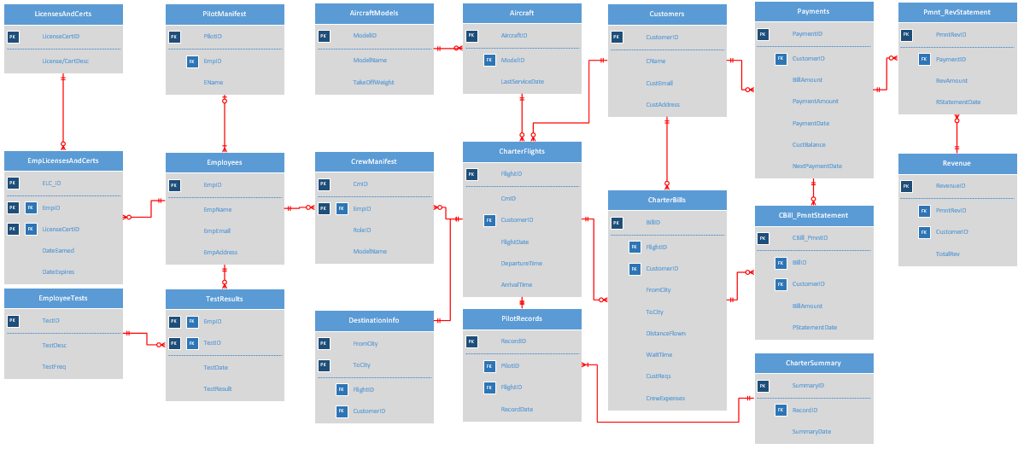

|  |
| --- |
| **Statement of Authenticity**  By putting my name below, I certify the work submitted in this document is my original work. Although collaboration with other individuals may have taken place, the final work is my own and submitted in full accordance with the Husson University Academic Integrity policy. |
| **Name:** *Gary Ward* |

|  |  |  |  |
| --- | --- | --- | --- |
|  | **Grade** | **Qualities Demonstrated by the Assignment Submission** | **Grade Assigned** |
| **Content (70%)**  **Measures the quality of the content in the assignment** | A+ 🡺 100 | The content demonstrates exceptional understanding of all relevant subject matter and its inter-relationships. All major relevant issues are thoroughly covered, and all content is very focused and on-topic. There is no known way to improve the content, and there are absolutely no technical or coverage errors present. |  |
| A 🡺 96 | The content demonstrates exceptional understanding of all relevant subject matter and its inter-relationships. All major relevant issues are thoroughly covered, and all content is very focused and on-topic. At most one insignificant technical or coverage error may be present |
| A- 🡺 92 | The content demonstrates deep understanding of all relevant subject matter and its inter-relationships. All major relevant issues are covered, and all content is on-topic. |
| B+ 🡺 88 | The content demonstrates understanding of all relevant subject matter and its inter-relationships. Almost all major relevant issues are covered, and the content is at least reasonably on-topic. |
| B 🡺 85 | The content demonstrates understanding of most relevant subject matter and its inter-relationships. Almost all major relevant issues are covered, and all content is at least reasonably on-topic. |
| B- 🡺 82 | The content demonstrates moderate understanding of much relevant subject matter and its inter-relationships. There is reasonable coverage of major relevant issues, and the content is at least reasonably on-topic. |
| C+ 🡺 78 | The content demonstrates some understanding of relevant subject matter and its inter-relationships. Some major relevant issues are covered, and at least some content is on-topic. |
| C 🡺 75 | The content demonstrates understanding of a small portion of the relevant subject matter and its inter-relationships. Some major relevant issues are covered, and at least a small portion of the content is on-topic. |
| C- 🡺 72 | The content demonstrates little understanding of and insight into the relevant subject matter and its inter-relationships. A small portion of the major relevant issues are covered. The focus of the content may be off topic or on insubstantial or secondary topics |
| D 🡺 67 | The content demonstrates almost no understanding of or insight into the relevant subject matter and its inter-relationships. Almost none of the major relevant issues are covered, and the content may be almost entirely off-topic. |
| F 🡺 0 | The content demonstrates no understanding of or insight into the relevant subject matter and its inter-relationships. No major relevant issues are covered, and the content is entirely off-topic. |
| **Exposition (30%)**  **Measures how well the content is expressed** | A+ 🡺 100 | The presentation of all ideas and designs is exceptionally clear and persuasive; the entire submission is exceptionally organized. There is no known way to improve the clarity or organization of the submission. |  |
| A 🡺 96 | The presentation of all ideas and designs is exceptionally clear and persuasive; the entire submission is exceptionally organized. There may be at most one insignificant way to improve the clarity or organization of the submission. |
| A- 🡺 92 | The presentation of all ideas and designs is very clear and persuasive; the entire submission is very organized. |
| B+ 🡺 88 | The presentation of all ideas and designs is clear and persuasive; the entire submission is organized. |
| B 🡺 85 | The presentation of most ideas and designs is clear and persuasive; most of the submission is organized. |
| B- 🡺 82 | The presentation of most ideas and designs is generally clear; most of the submission is reasonably organized. |
| C+ 🡺 78 | Some parts of the submission are hard to understand; some parts are disorganized. |
| C 🡺 75 | About half of the submission is hard to understand; about half is disorganized. |
| C- 🡺 72 | Most parts of the submission are hard to understand; most parts are disorganized. |
| D 🡺 67 | Almost all of the submission is hard to understand and disorganized. |
| F 🡺 0 | The entire submission is hard to understand and disorganized. |
|  | FINAL GRADE | |  |